**Assignment -1**

IOT

|  |  |
| --- | --- |
| Assignment Date | 19 September 2022 |
| Student Name | K.P.Sushmita |
| Student Roll Number | 910619104092 |
| Maximum Marks | 2 Marks |

**Question-1:**

Home automation using tinkercad.

|  |
| --- |
| **Solution:** |
| **#include <Keypad.h>**  **#include <LiquidCrystal.h>**  **#include <Servo.h>**  **#define Password_Length 5**  **Servo myservo;**  **LiquidCrystal lcd(A0, A1, A2, A3, A4, A5);**  **int pos = 0;**  **char Data[Password_Length];**  **char Master[Password_Length] = "1234";**  **byte data_count = 0, master_count = 0;**  **bool Pass_is_good;**  **bool door = false;**  **char customKey;**  **/*---preparing keypad---*/**  **const byte ROWS = 4;**  **const byte COLS = 4;**  **char keys[ROWS][COLS] = {**  **{'1', '2', '3', 'A'},**  **{'4', '5', '6', 'B'},**  **{'7', '8', '9', 'C'},**  **{'*', '0', '#', 'D'}**  **};**  **byte rowPins[ROWS] = {0, 1, 2, 3};**  **byte colPins[COLS] = {4, 5, 6, 7};**  **Keypad customKeypad( makeKeymap(keys), rowPins, colPins, ROWS, COLS);**  **/*--- Main Action ---*/**  **void setup()**  **{**  **myservo.attach(9, 2000, 2400);**  **ServoClose();**  **lcd.begin(16, 2);**  **lcd.print("Protected Door");**  **loading("Loading");**  **lcd.clear();**  **}**  **void loop()**  **{**  **if (door == true)**  **{**  **customKey = customKeypad.getKey();**  **if (customKey == '#')**  **{**  **lcd.clear();**  **ServoClose();**  **lcd.print("Door is closed");**  **delay(3000);**  **door = false;**  **}**  **}**  **else**  **Open();**  **}**  **void loading (char msg[]) {**  **lcd.setCursor(0, 1);**  **lcd.print(msg);**  **for (int i = 0; i < 9; i++) {**  **delay(1000);**  **lcd.print(".");**  **}**  **}**  **void clearData()**  **{**  **while (data_count != 0)**  **{**  **Data[data_count--] = 0;**  **}**  **return;**  **}**  **void ServoClose()**  **{**  **for (pos = 90; pos >= 0; pos -= 10) {**  **myservo.write(pos);**  **}**  **}**  **void ServoOpen()**  **{**  **for (pos = 0; pos <= 90; pos += 10) {**  **myservo.write(pos);**  **}**  **}**  **void Open()**  **{**  **lcd.setCursor(0, 0);**  **lcd.print("Enter Password");**    **customKey = customKeypad.getKey();**  **if (customKey)**  **{**  **Data[data_count] = customKey;**  **lcd.setCursor(data_count, 1);**  **lcd.print(Data[data_count]);**  **data_count++;**  **}**  **if (data_count == Password_Length - 1)**  **{**  **if (!strcmp(Data, Master))**  **{**  **lcd.clear();**  **ServoOpen();**  **lcd.print(" Door is Open ");**  **door = true;**  **delay(5000);**  **loading("Waiting");**  **lcd.clear();**  **lcd.print(" Time is up! ");**  **delay(1000);**  **ServoClose();**  **door = false;**  **}**  **else**  **{**  **lcd.clear();**  **lcd.print(" Wrong Password ");**  **door = false;**  **}**  **delay(1000);**  **lcd.clear();**  **clearData();**  **}**  **}** |
|  |
|  |
|  |
|  |
|  |
|  |
|  |
|  |
|  |

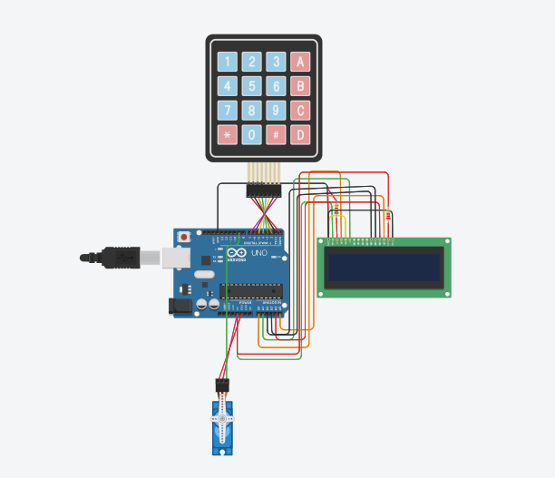

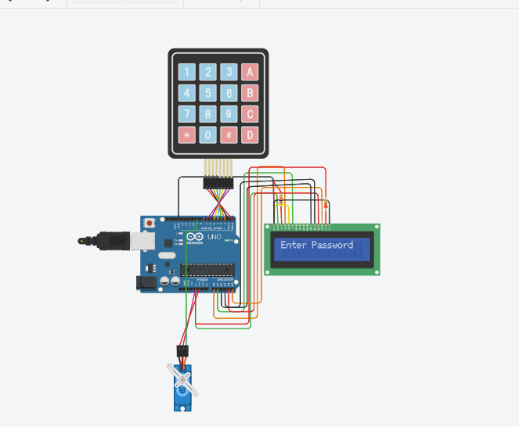

Link: [Circuit design home automation | Tinkercad](https://www.tinkercad.com/things/3AabRLQcp1u-home-automation/editel)